How To Look Up Multiple Measures In Ellucian (Datatel) Colleague
- Multiple measures are located in the same area of Ellucian (Datatel) Colleague you use to look up placement test scores (TSUM).

- Below is a screen shot of what you will see when you look up a multiple measure student.

- If the student shows a “Yes”, they have met Multiple Measures requirements. No math or English placement test is required. They can be enrolled in any math or English courses based on program requirements.
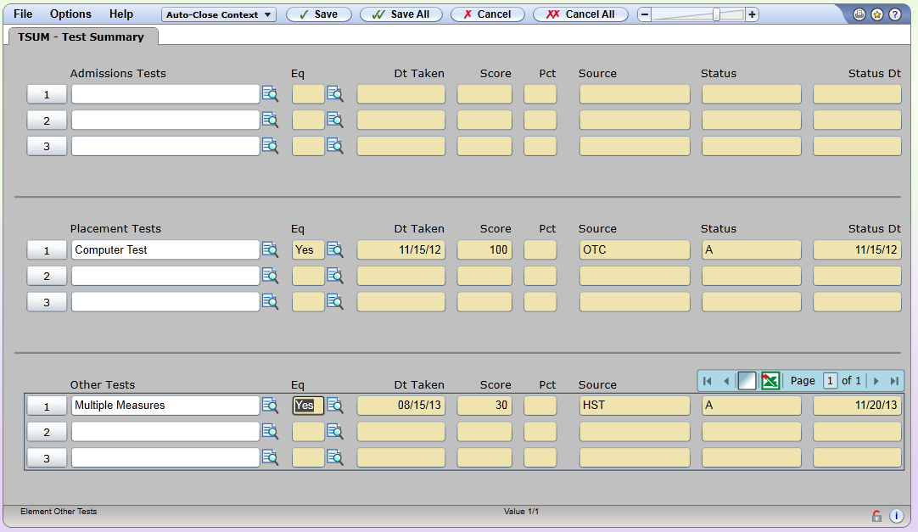
Multiple Measures
High School Transcript
Student GPA. Datatel does not do decimal points. 30 means 3.0

