Partnership Teach Elementary Education Models Full-time vs. Part-time Comparison

Consult with your Partnership Teach Coordinator to discuss which option is best for you.
 | Part-time Model | Full-time Model
Minimum GPA | 2.5 | 3.0
Prerequisite Course Requirement | Completion of all community college prerequisites recommended. May apply if 2 or fewer courses remain to be taken at the end of Spring term.  (Exceptions: EDU 216 and EDU 279  can be taken once enrolled) | ALL community college course prerequisites must be completed by end of Spring. (Exceptions: EDU 216 and EDU 279 can be taken once enrolled)
Praxis Core Test | Priority given to students with passing Praxis scores. | Passing scores required.
ECU Course Schedule | Approximately 3 classes (7-10 hours)  per semester until internship. | Approximately 5-6 classes (14-16 hours) per semester until internship.
Practicum Requirements | Varies but usually ranges from 12 – 40 hours per semester in a NC public school classroom. | Multiple practicum requirements resulting in significant hours in NC public  school classrooms each semester.
Two semester internship requirements | Internship I – 1 day per week for one semester Internship II – Full time internship for a full semester | Internship I – 1 day per week for one semester Internship II – Full time internship for a full semester
Recommended for | Working adults and/or students with multiple obligations outside of school. | Non-working adults and students who can devote full attention to academic work.
ECU Plan of Study  (after transfer) | 74-80 semester hours  24-26 courses  3 years | 74-80 semester hours  24-26 courses  2 years
Starting Term | Fall (August) | Summer (May)
Application Deadline | February 15 | January 15

Sample Part-Time Plan of Study Sample Full-Time Plan of Study
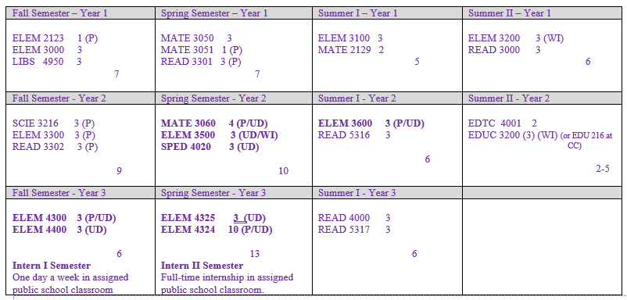
Full page sample planners can be viewed at https://education.ecu.edu/partnership

